Wumpus world in First Order Logic

Choose the correct answer:

1.First-order logic is another way of ______________

in artificial intelligence.

a) knowledge representation b) path detection

c) obstacle detection.

2.FOL is sufficiently expressive to represent the ___________ statements in a concise way.

a) foreign language b) natural language c) system language

3.A quantifier is a language element which generates _____________

a) prediction b) qualification c) quantification

4.Once you have the _________, your goal is to get back home.

a) gold b) Wumpus c) silver

5)Choose correct action that applied in wumpus world?

a) jump, run, search b) walk, sit, push c) Shoot, Grab, Climb.

2mark questions:

1.define First-order logic?

First-order logic is another way of knowledge representation in artificial intelligence. It is an extension to propositional logic.

FOL is sufficiently expressive to represent the natural language statements in a concise way.

First-order logic is also known as Predicate logic or First-order predicate logic. First-order logic is a powerful language that develops information about the objects in a more easy way and can also express the relationship between those objects.

2.what are the elements in First-order logic?

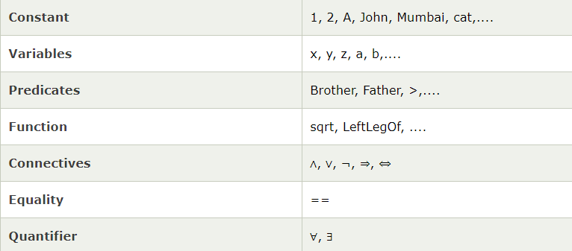

3.Explain the quantifiers in First-order logic?

A quantifier is a language element which generates quantification, and quantification specifies the quantity of specimen in the universe of discourse.

These are the symbols that permit to determine or identify the range and scope of the variable in the logical expression. There are two types of quantifier:

Universal Quantifier, (for all, everyone, everything)

Existential quantifier, (for some, at least one).

4.what are the two main parts in First-order logic?

Syntax

Syntax has to do with what ‘things’ (symbols, notations) one is allowed to use in the language and in what way; there is/are a(n):

* Alphabet
* Language constructs
* Sentences to assert knowledge

Semantics

Semantics: Formal meaning, which has to do what those sentences with the alphabet and constructs are supposed to mean.

5.How to work out actions to achieve the goal?

Inference: Lots more axioms. Explodes.

Search: Best-first (or other) search. Need to convert KB to operators

Planning: Special purpose reasoning systems.

10mark questions:

1)Describe wumpus world in First-order logic.

* Suppose an agent perceives a stench, breeze, no glitter at time t = 5:
  + Percept([Stench, Breeze, None],5)
  + [Stench, Breeze, None] is a *list*
* Then want to query for an appropriate action. Find an *a* (ask the KB):
* 
* Simplifying the percept and deciding actions
* 

Simple Reflex Agent



Agent Keeping Track of the World



Properties of locations:



Infer cause from effect:



Infer effect from cause:



* Causal rule doesn’t say if squares far from pits can be breezy.



Keeping track of the world is important

* Without keeping track of state...
  + Cannot head back home
  + Repeat same actions when end up back in same place
  + Unable to avoid infinite loops
  + Do you leave, or keep searching for gold?
* Want to manage time as well
  + *Holding(Gold, Now)* as opposed to just *Holding(Gold)*

Situation Calculus

* Adds time aspects to first-order logic  
    
  *Result* function connects actions to results



Describing actions

Pick up the gold!

Stated with an *effect axiom*



When you pick up the gold, still have the arrow!

Nonchanged: Stated with a *frame axiom*



* For each predicate (not action):
  + P is true afterwards means
    - An action made P true, OR
    - P true already and no action made P false
* Holding the gold:



2.Explain the difficulties with First-order logic.

* Frame problem
  + Need for an elegant way to handle non-change
  + Solved by successor-state axioms
* Qualification problem
  + Under what circumstances is a given action *guaranteed* to work? e.g. slippery gold
* Ramification problem
  + What are secondary consequences of your actions? e.g. also pick up dust on gold, wear and tear on gloves, etc.
  + Would be better to infer these consequences, this is hard

Keeping track of location

* Direction (0, 90, 180, 270)
* 
* Define function for how orientation affects x,y location
* 
* Define location ahead:
* 
* Define what actions do (assuming you know where wall is):
* 
* Primitive goal based ideas
* Once you have the gold, your goal is to get back home
* 
* _________Thank you_______